Insert organization logo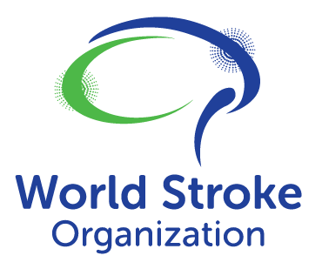

Dear [insert named MoH/govt contact]

Stroke focus at the 77th World Health Assembly
World Stroke Organization Policy Briefing, May 27th 5-7pm, Fairmont Hotel, Geneva
As representatives of the stroke community in [insert country] and as active members of the World Stroke Organization, we are writing to bring this event to your attention and to encourage the delegation of a government representative to this critically important event.
Part of the launch of a WSO policy briefing paper, United in Action to Transform Stroke Care will highlight key opportunities and strategies to reduce the growing global burden of stroke by advancing access to game-changing acute stroke treatments, including mechanical thrombectomy.
Stroke is a leading cause of death and disability worldwide. Globally, over 13 million people have a stroke each year, and over 100 million people living in the world are living with the consequences of stroke. The economic costs of stroke globally reached US$912b in 2017 and are projected to grow to US$1,590 in 2050.
The World Health Organization (WHO) reports that less than 50% of its member states explicitly included stroke in their non-communicable disease (NCD) preparedness plans and only 3% of WHO member states allocated funds specifically for stroke-related efforts. This event provides an opportunity for [insert country] to learn from knowledge leaders and share existing and potential policy interventions in response to global healthcare commitments.
Stroke treatment has made tremendous strides in improving patient outcome over the past decades. However, the relative recency of pivotal trials, combined with the requirement for stroke infrastructure to support broad access, means that high-quality stroke care is yet to be implemented in many countries. Increasing focus and capital spend is required in middle- and high-income countries to drive better stroke outcomes and to reduce lifetime costs of stroke related disability.
This event provides an excellent opportunity to both raise awareness of the global burden of stroke, and to explore policy and healthcare system solutions that will improve access to acute healthcare as part of Universal Health Coverage (UHC).
We strongly encourage your Ministry to delegate a representative to the meeting and to contribute expertise and perspectives to drive access to quality acute stroke care in [insert country] and around the world.
Your sincerely
[insert name, role and organization]

